
Thank you for taking the time to read the letter below regarding the MakatonLDND Campaign.



Dear put your MP’s name
You can find your MP with the link below
https://members.parliament.uk/members/commons

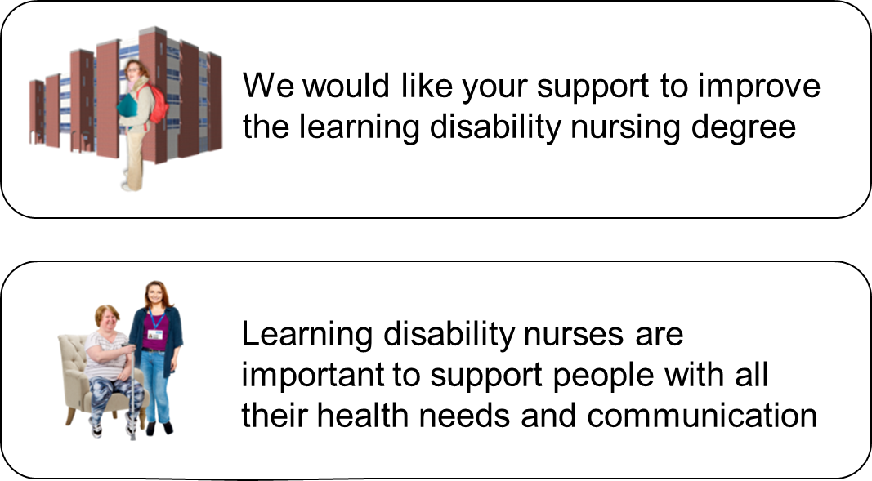

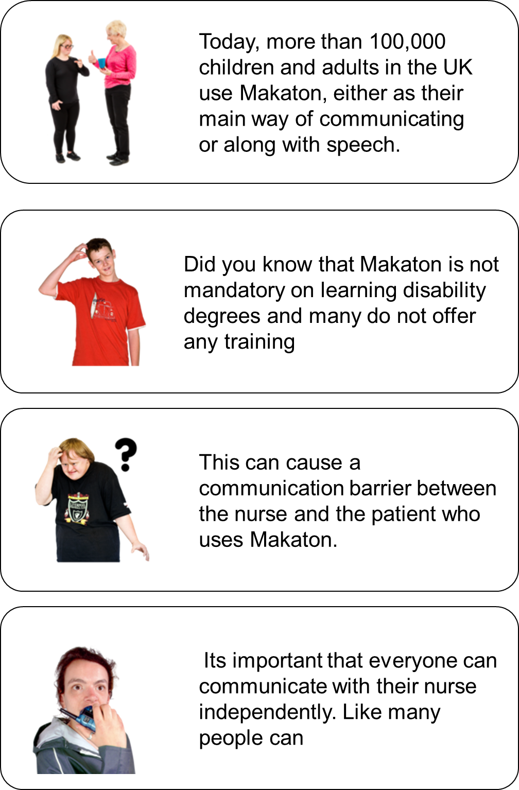

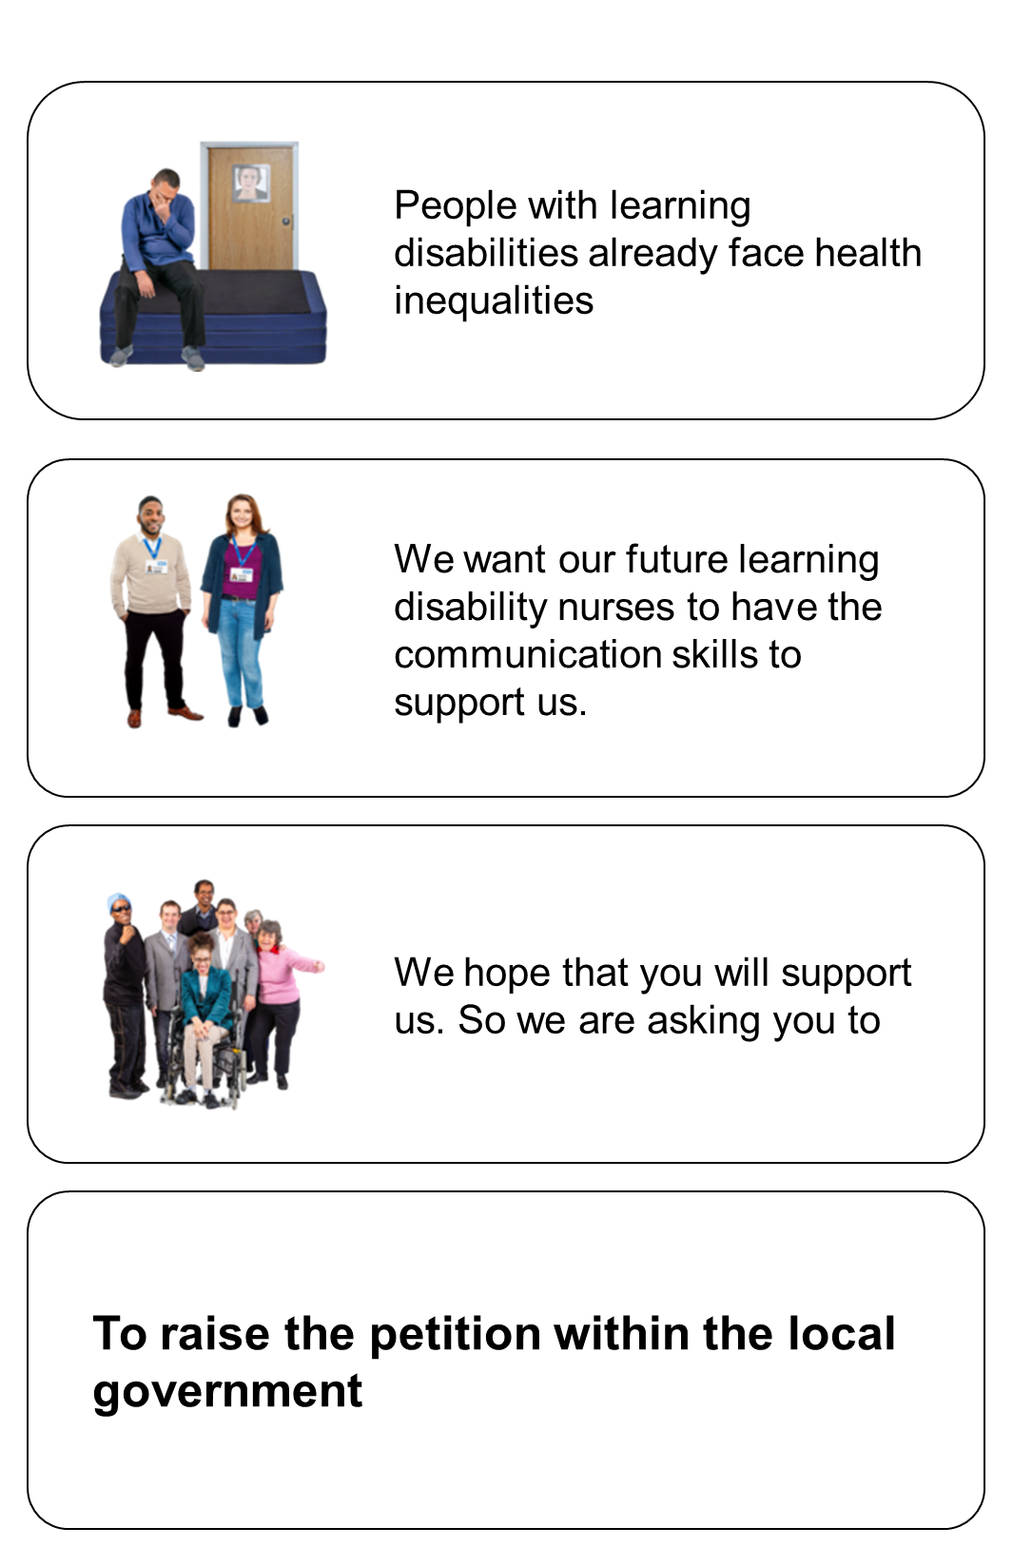
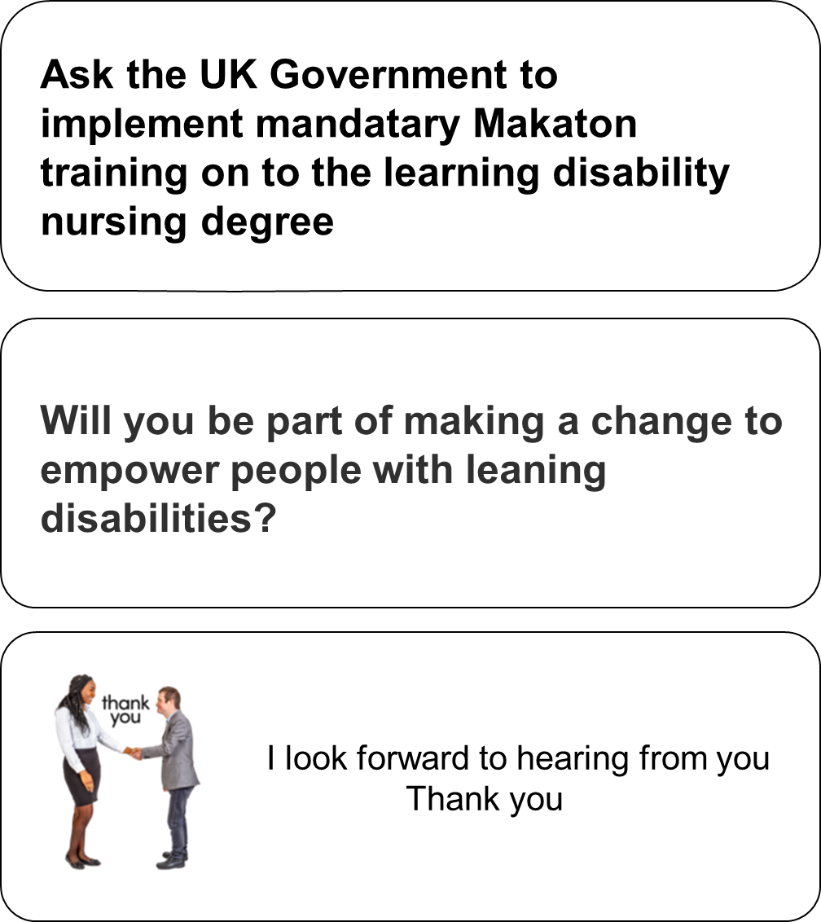

Your name and address
or email

makatonldnd@gmail.com
MakatonLDND Website –
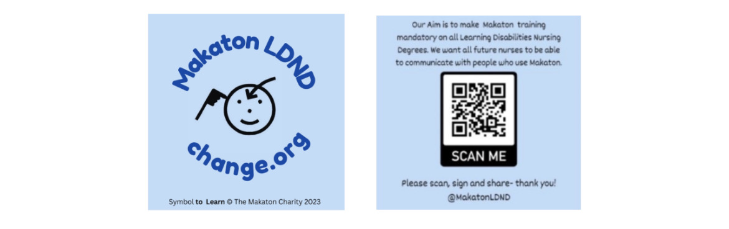
Our aim is to have Makaton a mandatory requirement on all Learning Disabilities Nursing Degrees, and integrated throughout the three years, so that future nurses will be able to communicate with people who use Makaton. Allowing them to independently communicate their needs and wishes without going through a third person. Empowering them and giving them reasonable adjustments.
makatonldnd@gmail.com
MakatonLDND Website –

makatonldnd@gmail.com
MakatonLDND Website –

 @MakatonLDND2023

